**Task 3**

1. WAP to check the free memory percentage and the alert message when the % is

greater than thershold

free -m

total - used free shared buff/cache available

Mem: 7929 1277 202 62 6449 6275

Swap: 0 0 0

total -used = free ( awk command )

convert this percentage

if the free space is less than 30

make alert message

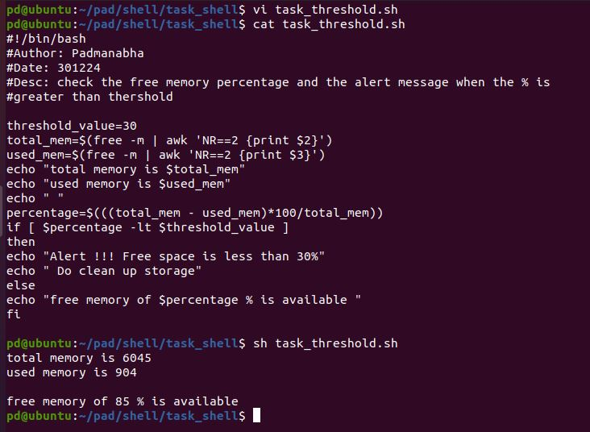

1. WAP to perform the below operation using case statement

take opr 1 2 3 4

free –m

df –h

du –h

uname –a

*) man –help

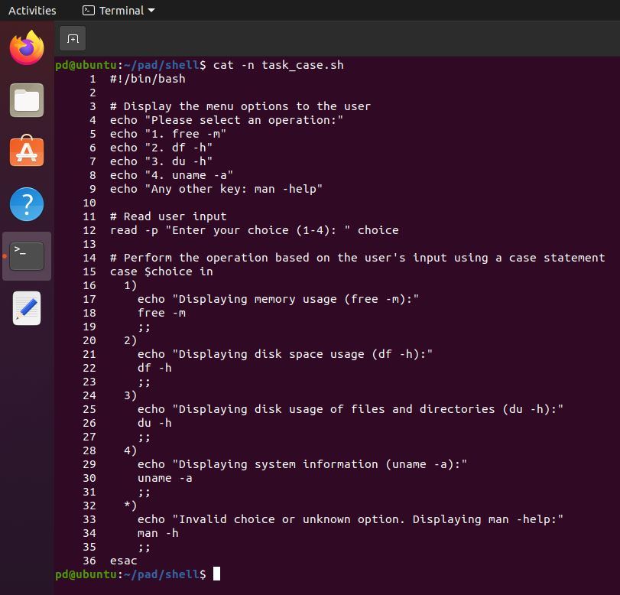

**O/p**

